1. **Write an algorithm for programmable problems:**
2. **Add two numbers**

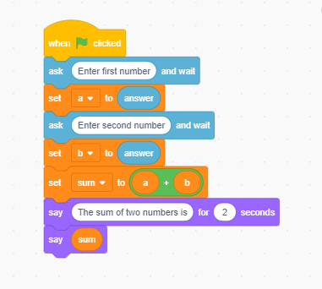

**\*\*\*Output\*\*\***

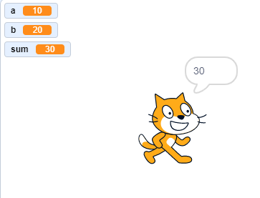

1. **Subtract two numbers**

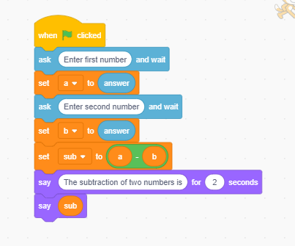

**\*\*\*Output\*\*\***

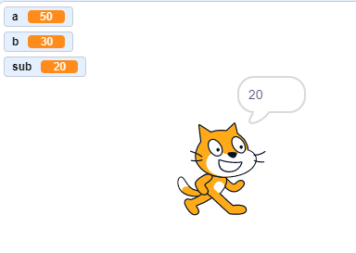

1. **Find the largest of 3 numbers**

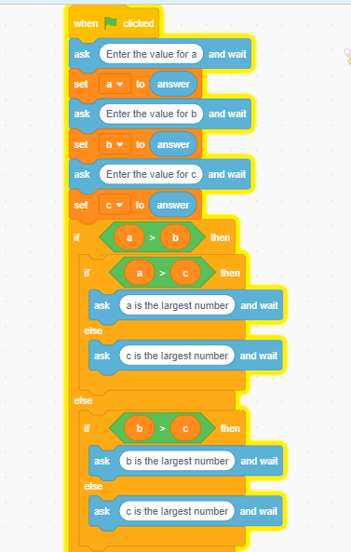

**\*\*\*Output\*\*\***

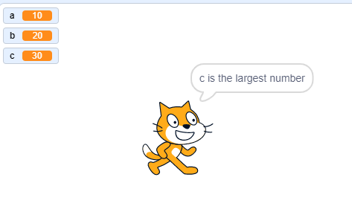

1. **Find the smallest of three numbers**

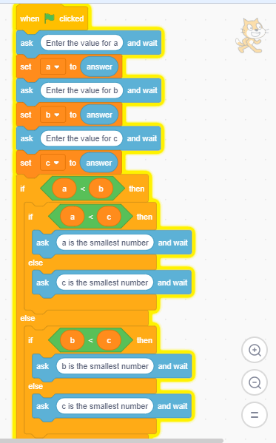

**\*\*\*Output\*\*\***

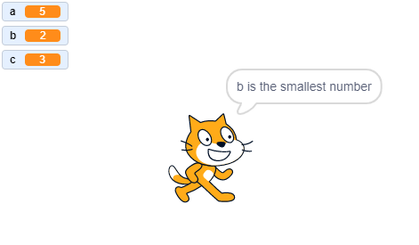

1. **Calculate and print sum of ‘N’ numbers.**

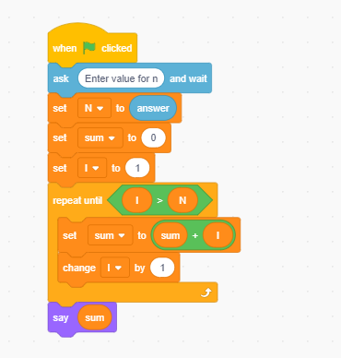

**\*\*\*Output\*\*\***

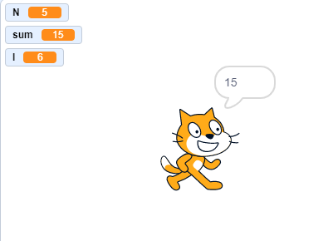

1. **Design a flowchart for programmable problems**
2. **Add two numbers**

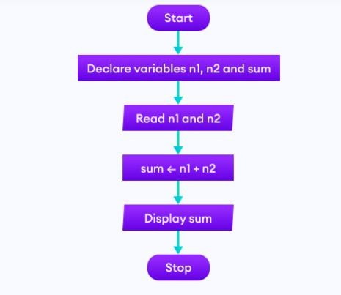

1. **Subtract two numbers**

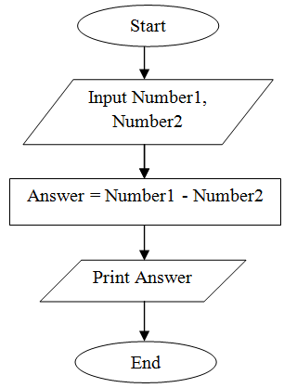

1. **Find the largest of 3 numbers**

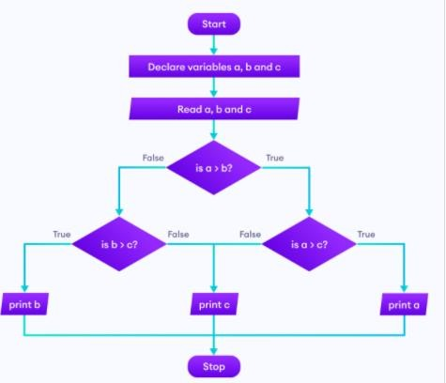

1. **Find the smallest of 3 numbers**

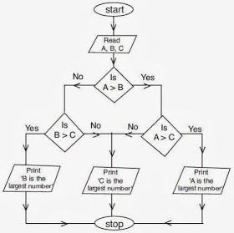

1. **Calculate and print sum of ‘N’ numbers.**

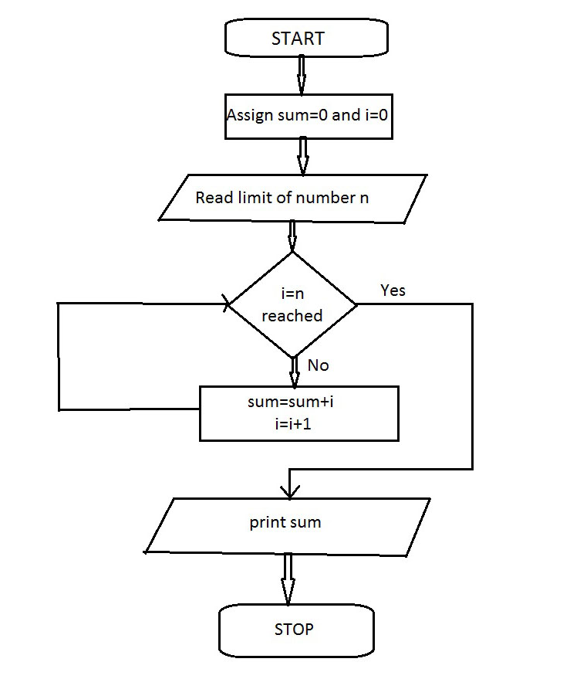

1. **Design and create simple game using scratch.**

**Chick and Egg game**

1. Create a sprite by clicking **“choose a sprite”** and select **chick**.
2. Write the code for chick as shown in fig.

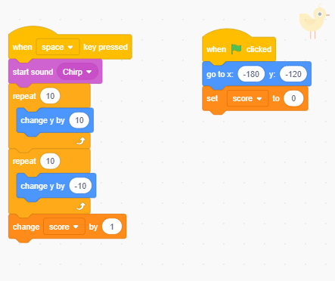

1. Create a another sprite by clicking **“choose a sprite”** and select **egg**.
2. Write the code for egg as shown in fig.

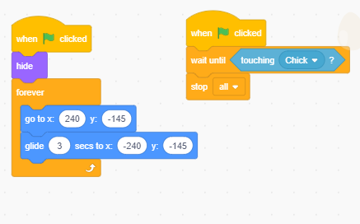

1. To create duplicate egg:- right click on egg sprite🡪select duplicate and write the code as shown in fig.

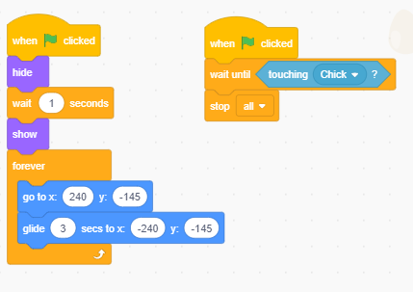

**\*\*\*Output\*\*\***

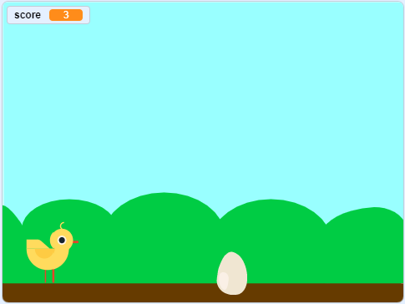

1. **Design and create a simple android application. (MIT App Inventor).**

MIT app inventor is used to develop applications for android phones using a web browser. MIT App Inventor is an online platform designed to teach computational thinking concepts through development of mobile applications. Students create applications by dragging and dropping components into a design view and using a visual blocks language to program application behavior.

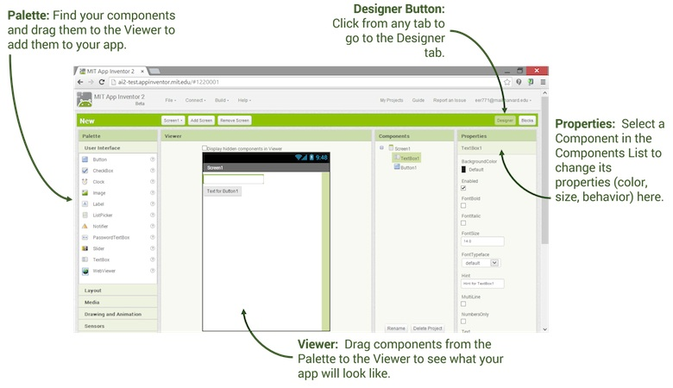

Fig. MIT App Inventor

To create a Talking Tom game steps are as follows:

1. Search MIT App Inventor on your computer using Google search, a page will open and select Create Apps.

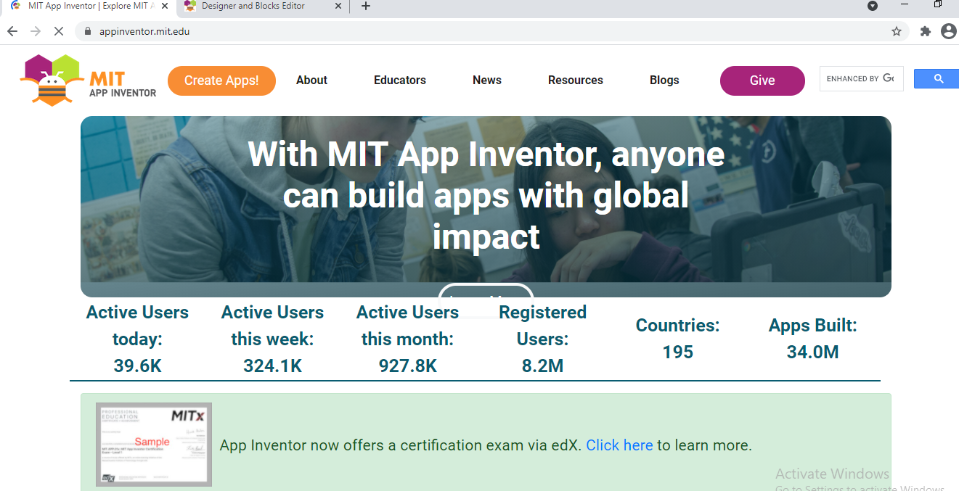

1. Sign in with Google. Select start new project and give the project name as Talking tom.

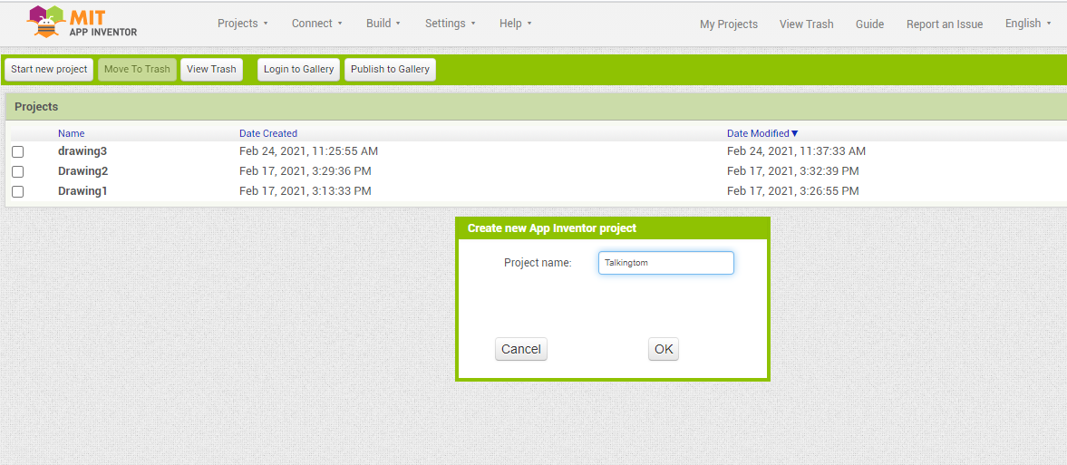

1. Download the Talking tom image from google and save it.
2. To add the image select **“image”** from user interface. On Properties window select Picture🡪Upload File🡪 Choose File🡪 OK. Select Height and width and click “Fill Parent”.

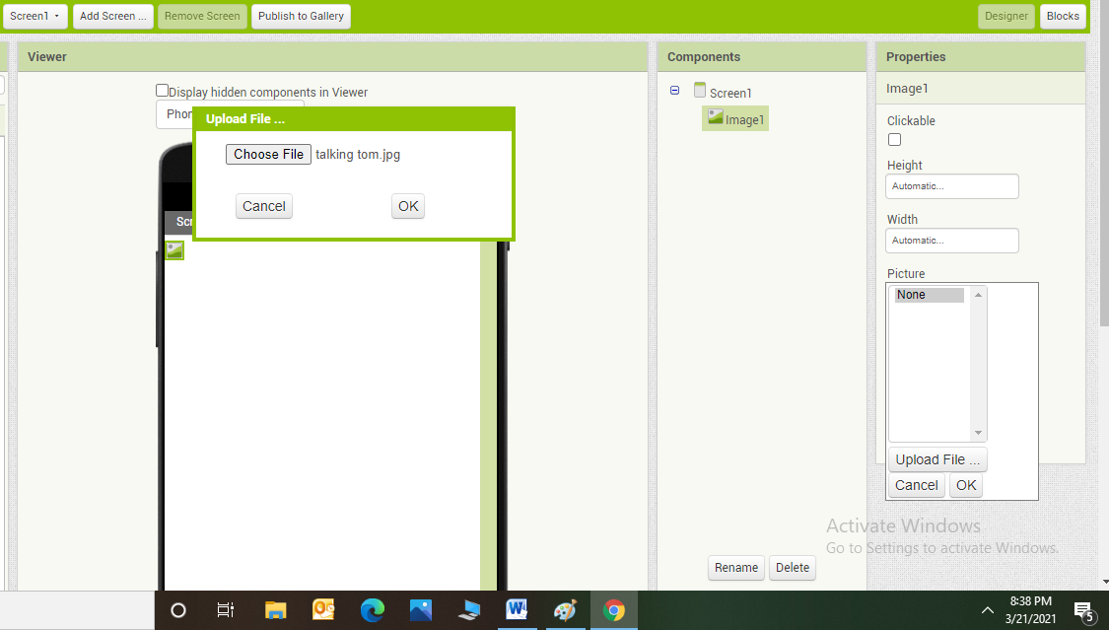

1. Select the “button” from user interface and give font as 20 and text as “Click here to speak” and click on FontBold.

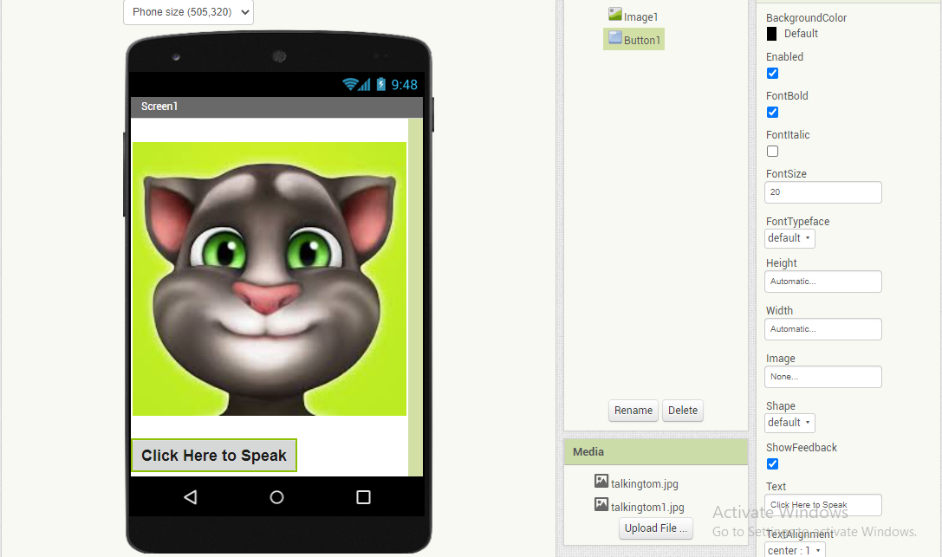

1. From Media select SpeechRecognizer and TextToSpeech.

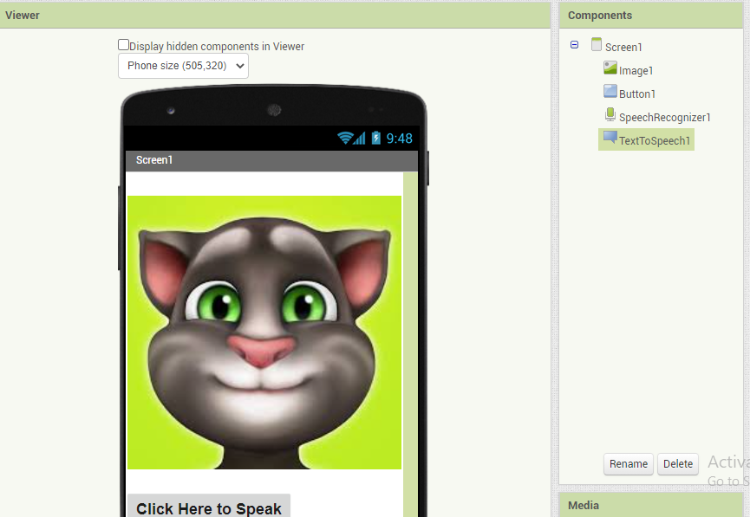

1. Write the code by clicking blocks for button and SpeechRecognizer as shown in fig.

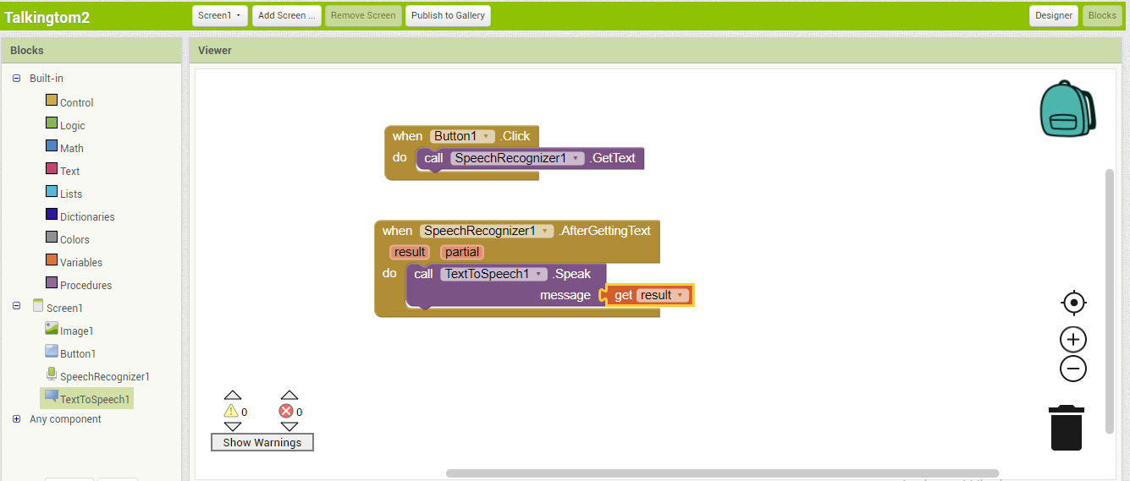

1. After writing code, select Build menu and click on App (provide QR code for .apk)

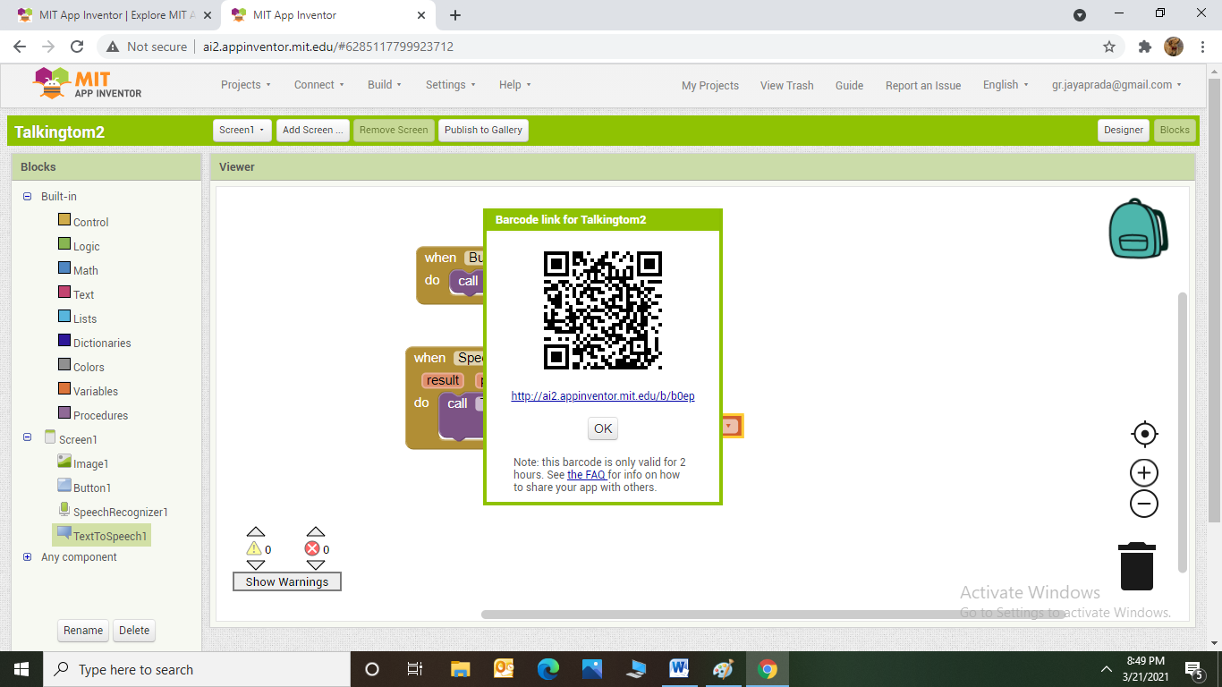

1. Install MIT A12 Companion app on your Smart phone and select QR code.
2. Install the talking tom app on your Smart phone and check the output.

